**02/08/2024 JAVA-CSA0983**

**1]create a array list and add all the cars name and display it.**

**Program:**

**import java.util.ArrayList;**

**public class Main {**

**public static void main(String[] args) {**

**ArrayList<String> carNames = new ArrayList<>();**

**carNames.add("Toyota");**

**carNames.add("Honda");**

**carNames.add("Ford");**

**carNames.add("Nissan");**

**carNames.add("BMW");**

**carNames.add("Audi");**

**System.out.println("Car Names are");**

**for (String carName : carNames) {**

**System.out.println(carName);**

**}**

**}**

**}**

**Output:**

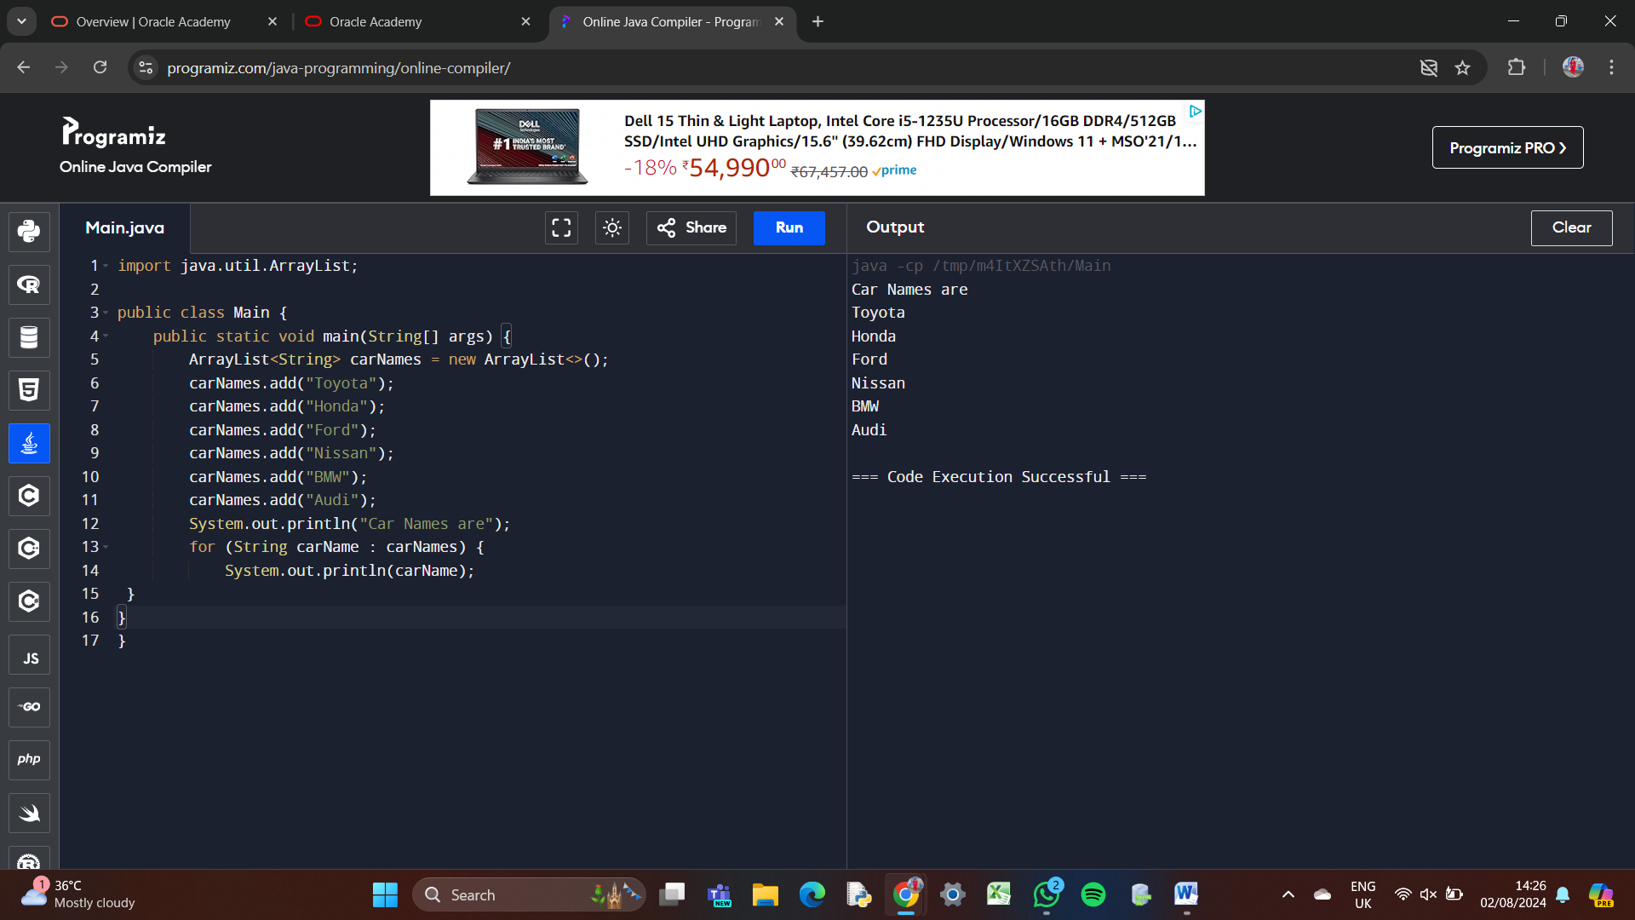

**2] write a java program to replace the 2nd element of arraylist with specified element.**

**Program:**

**import java.util.ArrayList;**

**public class Main {**

**public static void main(String[] args) {**

**ArrayList<String> list = new ArrayList<>();**

**list.add("Apple");**

**list.add("Banana");**

**list.add("Cherry");**

**list.add("Date");**

**list.add("Elderberry");**

**System.out.println("Original ArrayList: " + list);**

**String newElement = "Grape";**

**if (list.size() >= 2) {**

**list.set(1, newElement);**

**} else {**

**System.out.println("ArrayList does not have enough elements");**

**}**

**System.out.println("Modified ArrayList: " + list);**

**}**

**}**

**Output:**

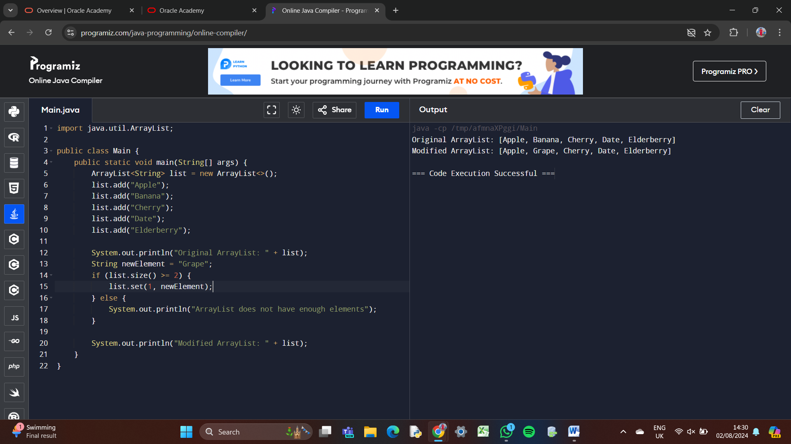

**3] write a java program to create an arraylist add some colors and display it.**

**Program:**

**import java.util.ArrayList;**

**public class Main {**

**public static void main(String[] args) {**

**ArrayList<String> colors = new ArrayList<>();**

**colors.add("Red");**

**colors.add("Green");**

**colors.add("Blue");**

**colors.add("Yellow");**

**colors.add("Purple");**

**System.out.println("Colors: " + colors);**

**}**

**}**

**Output:** 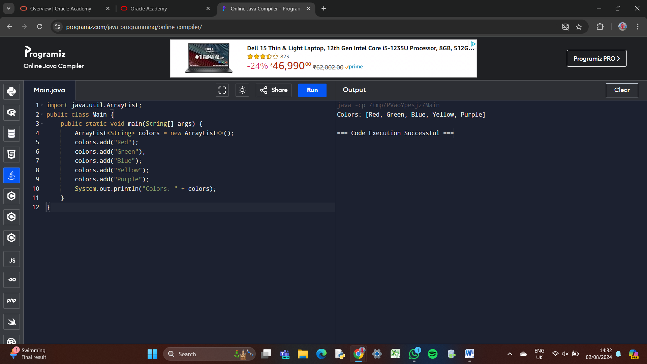

**4] write a java program to reverse the element in the array list.**

**Program:**

**import java.util.ArrayList;**

**import java.util.Collections;**

**public class Main {**

**public static void main(String[] args) {**

**ArrayList<String> colors = new ArrayList<>();**

**colors.add("Red");**

**colors.add("Green");**

**colors.add("Blue");**

**colors.add("Yellow");**

**colors.add("Purple");**

**System.out.println("Original Colors: " + colors);**

**Collections.reverse(colors);**

**System.out.println("Reversed Colors: " + colors);**

**}**

**}**

**Output:**

